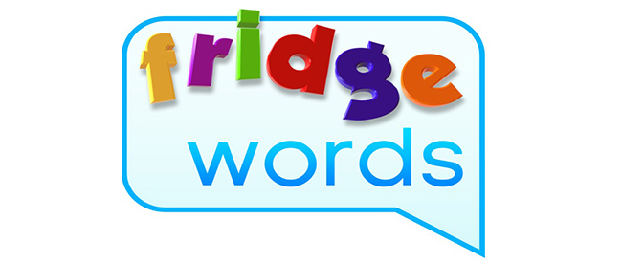
did
do
eat
four
get
Challenge words:
pumpkin
turkey
Thankgiving

