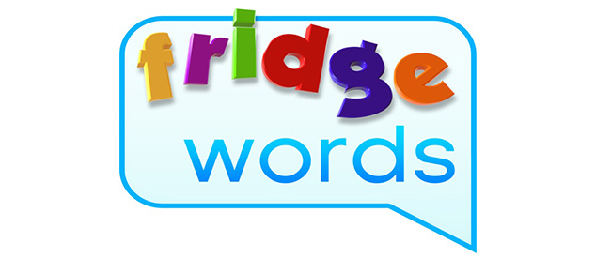
said
see
the
three
to
Challenge words:
trick
treat
visualize

