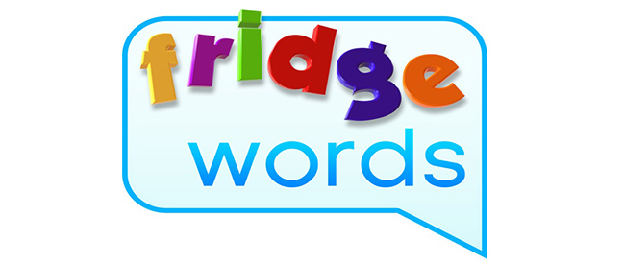
little
look
make
me
my

Challenge words:
October
beginning
middle

