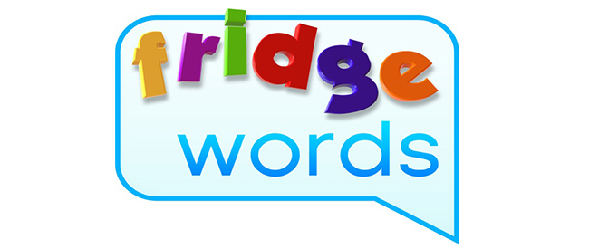
in
is
it
jump
little

Challenge words:
September
author
illustrator

